Type of sensations carried by nociceptors are:
A. Touch
B. Temperature
C. Pressure
D. Pain
ANSWER: D
Which type of receptors are present in the ear?
A. Chemoreceptors
B. Mechanoreceptors
C. Photoreceptors
D. Thermoreceptors
ANSWER: B
Which type of sensory structures carrying the touch sensations are present in papillae extending into ridges of the fingertips?
A. Hair end organs
B. Meissner's Corpuscles
C. Pacinian corpuscles
D. None of these
ANSWER: B
Which type of sensory structures carry deep pressure and vibration sensations?
A. Hair end organs
B. Meissner's Corpuscles
C. Pacinian corpuscles
D. none of these
ANSWER: C
Type of neurons found exclusively in CNS are:
A. Sensory neurons
B. Motor neurons
C. Associative neurons
D. None of these
ANSWER: C
Which of the following are responsible for the detection of changes in the environment?
A. Receptors
B. Neurons
C. Effectors
D. All of these
ANSWER: A
Pain receptors are technically called
A. chemoreceptors
B. photoreceptors
C. nociceptors
D. mechanoreceptors
ANSWER: C
________detech changes in temperature
A. chemoreceptors
B. photoreceptors
C. nociceptors
D. thermoreceptors
ANSWER: D
Light-detecting sensory cells are called
A. chemoreceptors
B. photoreceptors
C. nociceptors
D. thermoreceptors
ANSWER: B
_____ detect chemicals dissolved in fluid medium surrounding them
A. chemoreceptors
B. photoreceptors
C. nociceptors
D. thermoreceptors
ANSWER: A
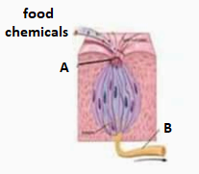
Identify the given diagram
A. Taste buds on tongue
B. olfactory receptors in nasal epithelium
C. receptors in human skin
D. receptors of pain
ANSWER: A

Identify the structure A in the diagram?
A. tubes
B. cilia
C. Taste nerve to brain
D. Taste bud pores
ANSWER: D
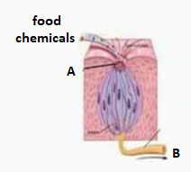
Identify the structure B in the diagram?
A. tubes
B. cilia
C. Taste nerve to brain
D. Taste bud pores
ANSWER: C
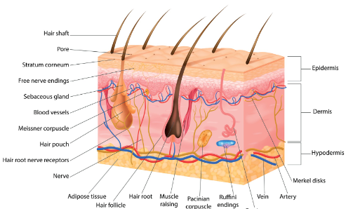
A. Taste buds on tongue
B. olfactory receptors in nasal epithelium
C. receptors in human skin
D. receptors of pain
ANSWER: C
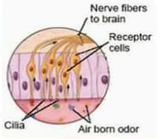
A. Taste buds on tongue
B. olfactory receptors in nasal epithelium
C. receptors in human skin
D. receptors of pain
ANSWER: B

